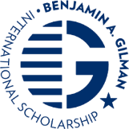
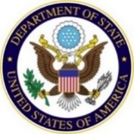

FOR IMMEDIATE RELEASE
Date: 6/2024

U.S. Department of State Selects University of Maryland, Baltimore County, to Host Gilman Advisor Workshop

June XX, 2024 – The U.S. Department of State’s Bureau of Educational and Cultural Affairs (ECA) and the Benjamin A. Gilman International Scholarship Program (Gilman Program) have selected the University of Maryland, Baltimore County, to host an in-person Gilman Advisor Workshop on Friday, October 25, 2024. This workshop will convene 50 Gilman campus advisors from across the United States to build and strengthen the Gilman Program through networking and sharing strategies for supporting students from the application phase through returning to the United States as Gilman alumni.

The University of Maryland, Baltimore County, will lead interactive professional development sessions that include strategies for outreach, Gilman application growth, supporting first generation and underrepresented students in the application process, peer mentor support, and Gilman alumni development. Attendees will also learn from each other’s experiences on recruiting and supporting Gilman applicants, recipients, and alumni at their respective institutions.

Since the program’s inception in 2001, more than 41,000 Gilman Scholars from all U.S. states, the District of Columbia, Puerto Rico, and other U.S. territories have studied or interned in more than 160 countries around the globe. The U.S. Department of State awarded approximately 3,000 Gilman scholarships during the 2022-2023 academic year. On average, 70 percent of Gilman recipients self-identify as racial or ethnic minorities, 60 percent are from rural areas and small towns across America, and half are first generation college or university students. All are Pell Grant recipients. The Gilman Scholarship contributes to the Department’s efforts to engage the American people in foreign policy.

Supported by the U.S. Congress, the Gilman Program is an initiative of the U.S. Department of State’s Bureau of Educational and Cultural Affairs (ECA) and is aided in its implementation by the Institute of International Education (IIE). To learn more about the Gilman Program and its recipients, including the roles of Gilman campus advisors, visit gilmanscholarship.org.

